Lifecycle Events

Voyager Duo Activation – Associates and NEP

Lifecycle Event Details
Attribute | Value
Lifecycle Event Name | Voyager Duo Activation – Associates and NEP
Lifecycle Event Type | Rule
Workflow Name | Voyager Duo Activation

Event Rule Logic
The lifecycle event is triggered when the following Hire Date condition is satisfied:
- HIRE_DATE must be either:
  - Equal to today’s date, or
  - Within the next 3 days from the current date.

Additional Event Criteria
The lifecycle event will execute only when the following conditions are satisfied:
- Identity Attribute Validation
  - The identity attribute inactive must not be equal to "true".
- Worker Type Validation
  - WorkerType must be one of the following values:
    - E (Employee)
    - P (Pending Worker)
    - C (Contractor / NEP)

- Joiner Status Validation
  - The joinerStatus attribute must contain one of the following values:
    - PreHire Associate Completed
    - NewHire NEP Completed
    - Rehire Associate Completed
    - Rehire NEP Completed

Flow Chart
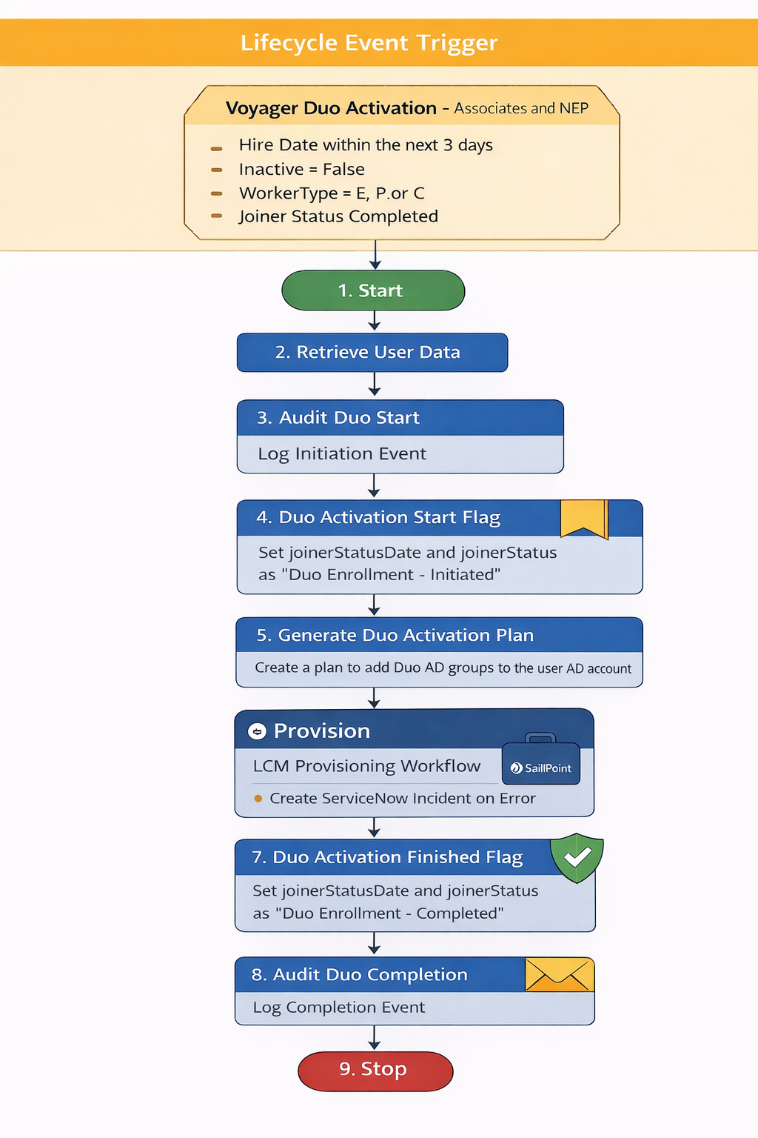

Step Summary

Step Summary
Step No | Step Name | Description
1 | Start | Initiates the workflow when lifecycle event criteria are satisfied.
2 | Retrieve User Data | Retrieves required identity attributes for processing and auditing.
3 | Audit Duo Start | Logs the initiation of the Duo enrollment event.
4 | Duo Activation Start Flag | Updates identity attributes to indicate the Duo enrollment process has started.
5 | Generate Duo Activation Plan | Builds a provisioning plan to assign Duo AD groups based on market mapping.
6 | Provision | Executes the provisioning plan and creates a ServiceNow incident if errors occur.
7 | Duo Activation Finished Flag | Updates identity attributes to indicate successful Duo enrollment completion.
8 | Audit Duo Completion | Records an audit event confirming successful Duo enrollment.
9 | Stop | Ends the workflow execution.

Workflow Description

Workflow: Voyager Duo Activation

Step 1 – Start
The workflow begins execution once the lifecycle event criteria are satisfied.

Step 2 – Retrieve User Data
The workflow retrieves the required identity attributes from SailPoint to support the Duo activation provisioning process.

Retrieved Attributes
- employeeType
- assignmentAction
- assignmentStatusTypeCode
- hireDate
- firstname
- lastname
- employeeId
- departmentNumber
- managerPersonNumber
These attributes are stored as workflow variables and used in subsequent steps for auditing, provisioning logic, and notifications.

Step 3 – Audit Duo Start
An Audit Event is created to record the initiation of the Duo activation process.

Audit Event Details
- Audit Name:
Initiated - Duo Enrollment Event
- Captured Data:
All retrieved identity attributes are logged to maintain traceability and compliance.
This audit entry confirms that the Duo enrollment process has been triggered for the identity.

Step 4 – Duo Activation Start Flag
The workflow updates identity attributes to indicate that the Duo activation process has started.

Identity Attribute Updates
Attribute | Value
joinerStatusDate | Current Date
joinerStatus | Duo Enrollment - Initiated
This status flag helps track the progress of the Duo enrollment lifecycle process.

Step 5 – Generate Duo Activation Plan
The workflow constructs a Provisioning Plan to assign Duo authentication groups to the user's Active Directory account.

Provisioning Logic
- The workflow references the Custom Object:
Ascension-Custom-AD-DomainMapping
- The custom object contains the following key mappings:
Mapping | Purpose
DNMapping | Maps the user’s market/domain to the appropriate AD application and Distinguished Name (DN).
duoGroups | Contains the Duo AD group details associated with each DN entry.
- Based on the user's Market attribute, the workflow:
- Determines the appropriate AD domain
- Identifies the DN entry
- Retrieves the associated Duo AD groups
- A ProvisioningPlan is generated to:
- Add the user's AD account to the required Duo enrollment groups
These group memberships enable the user for Duo multi-factor authentication enrollment.

Step 6 – Provision
The provisioning plan is executed using the Voyager LCM Provisioning Workflow.

Provisioning Execution
- The provisioning engine processes the generated plan.
- Requests are sent to the respective Active Directory connectors.

Error Handling
After provisioning:
- The workflow evaluates the ProvisioningResult from the ProvisioningProject.
If errors or warnings are detected:
- A ServiceNow Incident Ticket is automatically created.
- The ticket contains:
  - User details
  - Provisioning request information
  - Error messages and failure details
This ensures operational visibility and prompt issue resolution.

Step 7 – Duo Activation Finished Flag
Upon successful provisioning, the workflow updates the identity status to indicate completion of Duo enrollment.

Identity Attribute Updates
Attribute | Value
joinerStatusDate | Current Date
joinerStatus | Duo Enrollment - Completed
This confirms that the user has been successfully assigned the required Duo authentication groups.

Step 8 – Audit Duo Completion
An audit record is created to log the successful completion of the Duo enrollment process.

Audit Event Details
Field | Value
Audit Name | Completed - Duo Enrollment Event
Captured Data | All retrieved identity attributes
This provides a complete audit trail for compliance and operational tracking.

Step 9 – Stop
The workflow execution ends after the Duo enrollment completion audit event is recorded.

